**DAILY ONLINE ACTIVITIES SUMMARY**

|  |  |  |  |  |  |  |  |
| --- | --- | --- | --- | --- | --- | --- | --- |
| **Date:** | **11-07-2020** | | | | **Name:** | **B.A.SOHANKUMAR** | |
| **Sem & Sec** | **4th SEM A** | | | | **USN:** | **4AL18CS013** | |
| **Online Test Summary** | | | | | | | |
| **Subject** | | **----** | | | | | |
| **Max. Marks** | | **----** | | **Score** | | **----** | |
| **Certification Course Summary** | | | | | | | |
| **Course** | **STATISTICAL METHODS FOR DECISION MAKING** | | | | | | |
| **Certificate Provider** | | | **GLA** | **Duration** | | | **7 HOURS** |
| **Coding Challenges** | | | | | | | |
| **Problem Statement:1:Write a Java program for Reversal algorithm for array rotation by 3.** | | | | | | | |
| **Status: EXECUTED** | | | | | | | |
| **Uploaded the report in Github** | | | | **YES** | | | |
| **If yes Repository name** | | | | **https://github.com/sohannaik5648987/DAILY-REPORTS** | | | |
| **Uploaded the report in slack** | | | | **YES** | | | |

**CERTIFICATION COURSE DETAILS:**

Course: STATISTICAL METHOD FOR DECISION MAKING

Today I have opted this new course and this course has the video content of 7hours and it consists of one assessment quiz.Completed topics today are Overview of the Course,Measures of Central Tendency,Measures of Dispersion,Working with R - Part 1,Working with R - Part 2,CardioGoodFitness.csv,PelicanStores.xlsx,Descriptive Statistics,Statistics Overview.

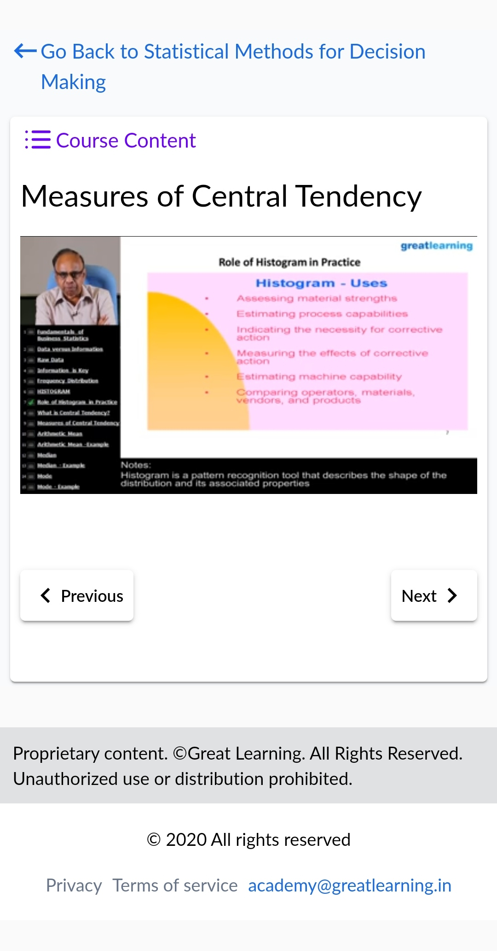 

**CODING CHALLENGES:**

1.Write a Java program for Reversal algorithm for array rotation by 3 .Given an array a[], array size n and d the number of index to be rotated task is to write a function rotate(arr[],d,n) that rotates arr[] of size n by d elements.

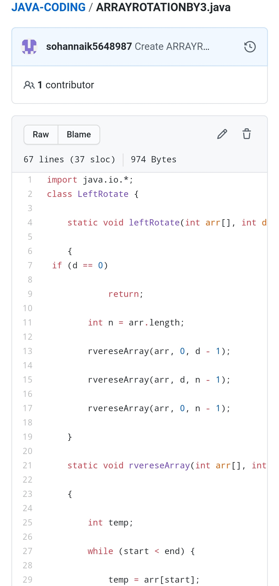

REPOSITORY LINK:https://github.com/sohannaik5648987/JAVA-CODING